Sandra Dyke
Sandra.dyke@nmit.ac.nz
Using Word Features
to enhance a document

Contents Page
Layout of the Document – Heading 1 1
Add a Title Page – Heading 2 1
Using Headers and Footers – Heading 1 2
Adding Headers and Footers – Heading 2 2
Adding Quick Parts – Heading 2 3
Customising Headers and Footers – Heading 2 3
Adding Page Numbers – Heading 2 4
Page Number Format – Heading 2 5
Adding Section Breaks – Heading 2 5
Issues with Headers and Footers 7
Page Breaks and Section Breaks – Heading 2 8
Table of Contents – Heading 1 10
Using Styles – Heading 2 10
Modifying Styles – Heading 2 12
Creating New Styles – Heading 2 13
Making Styles work for you – Heading 2 14
Creating a Table of Contents – Heading 2 15
Some issues with the Table of Contents – Heading 2 16
Updating a Table of Contents – Heading 2 17
Referencing – Heading 1 18
Adding APA References – Heading 2 18
Creating a Reference Page – Heading 2 21
Cross Referencing Figures – Heading 2 22
Other Types of Cross References – Heading 2 25
Creating a Table of Figures – Heading 2 26
A Final Word – Heading 1 26
References 27

Table of Figures
Figure 1: 5 Pointed Star 23
Figure 2: 6 Pointed Star 23

Layout of the Document – Heading 1

Add a Title Page – Heading 2
Templates are available from the INSERT Cover Page Option
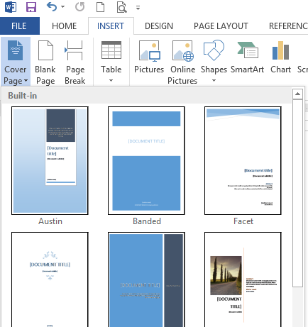
The cover page will be added to the start of the document
Update the information required

Activity
All work related to activities should be completed in your copy of the Using Word 2016 Starting document
Add a cover page of your choice to Using Word 2016 Starting document and personalise it

Using Headers and Footers – Heading 1
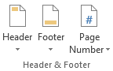
Location: INSERT tab

Adding Headers and Footers – Heading 2
Click the drop-down arrow to choose an option – the Blank options have placeholders for text already formatted with the required tabs.
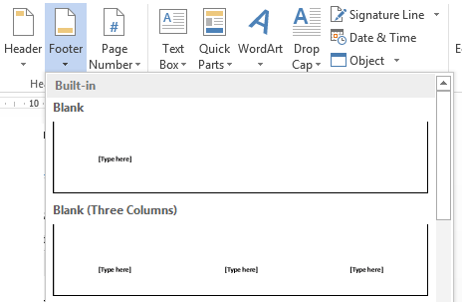
Text added to the header or footer appears within the margins of the page
When the header or footer is closed, the text is a lighter colour
Activity
Add a Blank (Three Columns) Footer
Add Your Name on the left hand side
Add the Year on the right hand side

Adding Quick Parts – Heading 2
Other information can be added using Document Information and Quick Parts in the HEADER & FOOTER TOOLS DESIGN tab
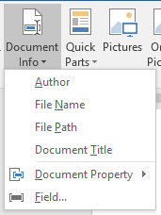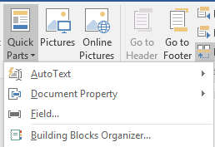
The File Name field is particularly useful because it adds the name the file has been saved as which makes it easier to find. The File Path option includes the path to where the document is saved on your computer.

Customising Headers and Footers – Heading 2
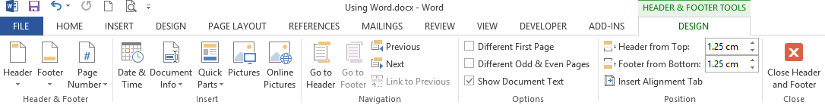
Once a header or footer has been created it can be easily modified by double clicking inside the header or footer area to activate it and then typing whatever is required or inserting the required information from the contextual HEADER & FOOTER TOOLS DESIGN tab
Creating Different Headers and Footers in a Document – Heading 2
It is possible to have different headers and footers throughout the document
Double click on the header or footer to display the contextual HEADER & FOOTER TOOLS DESIGN tab
Select the option required and then make the changes required – Different First Page is useful if sections breaks are not going to be used, otherwise there can be issues with blank footers!

Adding Page Numbers – Heading 2
Use the Page Number option to add the page number – the easiest way is to click in the footer where the page number is to go and use the ‘Current Position’ option otherwise the current footer details maybe overwritten!
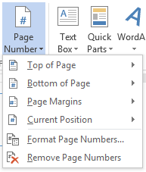
Activity
Update the Footer as shown below (NB the actual page number you see may be different)
Type the word ‘Page’ in front of the page number shown
Check that Different First Page is NOT selected or else section breaks will cause some issues with the footer on the first page of each section (usually disappear!)

Page Number Format – Heading 2
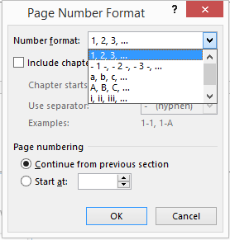
Different formats can be used for different parts of the document
Use Section Breaks (rather than Page Breaks) for this to work effectively

If the page numbering isn’t working as required check the Page numbering section of the dialogue
Numbering can be started at any number or continue from the previous numbering

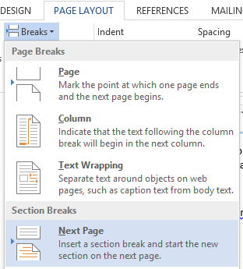
Adding Section Breaks – Heading 2
To have different headers and footers for different sections of the document use Section Breaks to mark different sections of the document.
Click on the document where the new section is to start
Click PAGE LAYOUT BREAKS NEXT PAGE to insert the section break. All the text following the section break will be moved to start on a new page.

To change the details for the Header or Footer, ensure the ‘Link to Previous’ is deselected

Activity
Click to the left of the heading ‘Layout of the Document’ at the start of your document
Add a section break – Next Page
Double click in the footer for Footer - Section 2
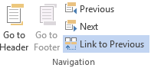
Click Link to Previous to unselect it

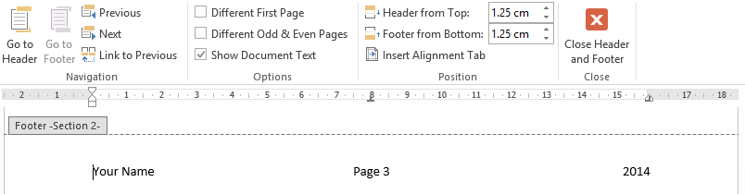
Double click in the footer on the Table of Contents page
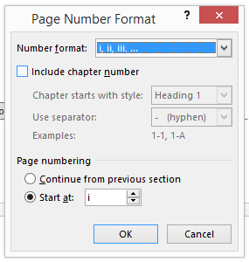
Highlight the page number and select Format Page Number in the Header Footer section

Change the number format to roman numerals and start at i

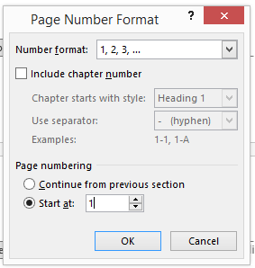
Double click in the footer for the first page of the actual document and change the start number to 1

Go back to the cover page (which should show a footer) and change the footer option to ‘Different First Page’ to remove the footer details
Result of the above actions should be
- Cover page – no footer details
- Contents page – footer details with page number as i
- Layout of the Document page – footer details with page number as 1

Issues with Headers and Footers
Sometimes the information in the headers and footers is not what you want it to be. This is usually a result of the page breaks and section breaks being in the wrong places.
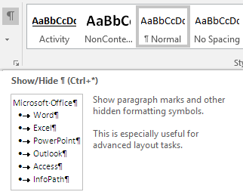
To fix these issues
HOME tab click on Show/Hide and delete or add in formatting as required.
Common formatting symbols include:
for enter/returns
spaces
tabs
Don’t worry though as these won’t be printed out as they are hidden formatting symbols.

Page Breaks and Section Breaks – Heading 2
Page breaks are useful for easily moving text on one page to start at the top of the next page. One method of moving text is to continually use the Enter key. The problem with this method is when more text is applied to the first page, the text moved to the start of the next page will also have moved down the page. The use of a page break, on the other hand, will still move the text to the start of the new page but when text is added to the previous page it will not move the text on the next page.
Page Breaks can be added from the INSERT tab or the PAGE LAYOUT tab.
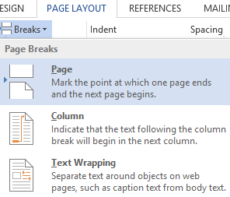
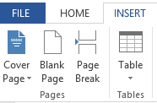

Section Breaks are useful for using different heading and footers as mentions previously.
They are also useful for changing page orientation for different pages or sections of a document.
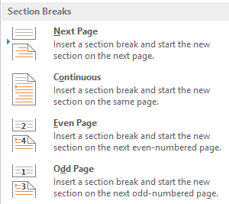
The Section Break option is found in the Breaks section of the PAGE LAYOUT tab.
The Next Page option is best for manually adding section breaks.

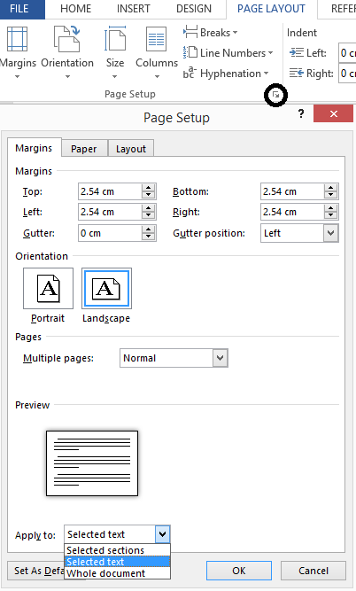
Another method for changing the layout of part of a document is to highlight the required text and use the Page Setup options from the PAGE LAYOUT tab.
This method is useful when only part of the document needs to have the page orientation changed.
Activity
In the Using Word 2016 Starting document you are currently working on:
Highlight the text and image on this page
Open the Page Setup options and change:
Orientation to Landscape
Apply to This Section
Click OK
Check the page number of this page and the next page as it may need to be reformatted.
Delete the PAGE break on the next page
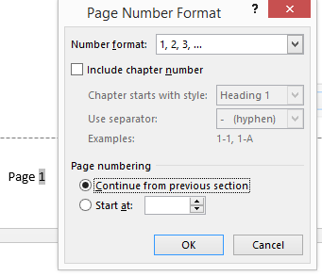

Table of Contents – Heading 1
A table of contents can be added to a Word document which will automatically add headings and page numbers provided the document is set up using heading styles.

Using Styles – Heading 2
Word comes with a number of styles already set up. It is also possible to modify and create your own styles. Each style comes with its own set of properties which can be changed as required. Styles are a quick way of having consistent text within the document. It allows for easy updating of text from style to another.
These can be found on the Home Tab
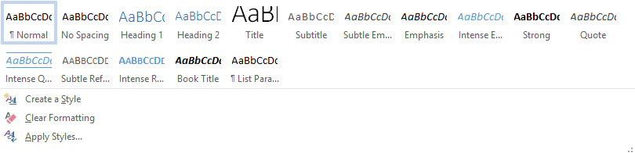
An alternative method of displaying these styles is to dock them to the side of the screen.
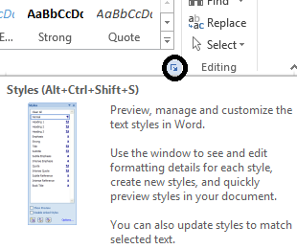
To do this click on the arrow to open the styles box and then click and drag the styles box to a suitable place

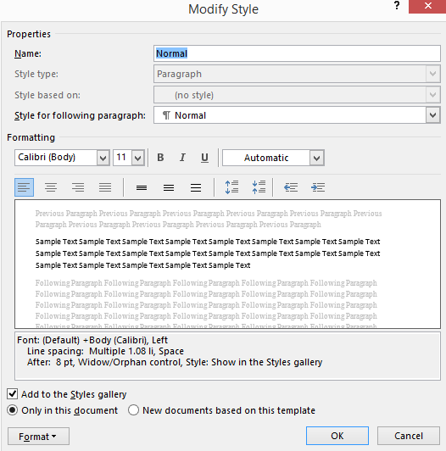

To apply a style first click on the text required and then click the desired style. If the style is to be applied to a heading or a paragraph, just clicking on within the line or paragraph is all that is needed. Hovering over the style will give a preview of the final result. Clicking on the style will apply it.
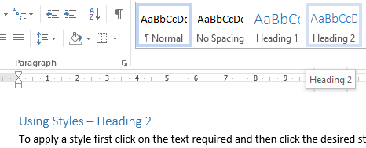
Activity
Apply the Heading 1 or Heading 2 style to each heading in your document.
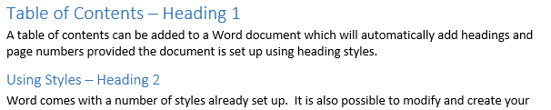

Modifying Styles – Heading 2
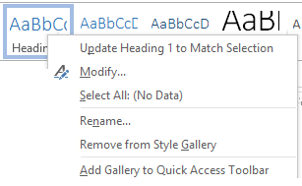

Right click on the style name to be modified
Click on the Modify option to open the Modify Styles properties dialogue.

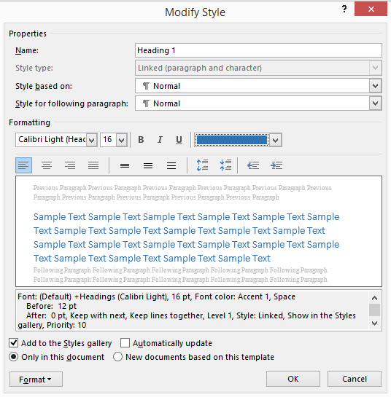

Change any of the properties required.

The Format drop down arrow (at the bottom) provides more options.

Click on OK

Activity
Change the Heading 1 style in your document so the colour is Black and text is in Bold (click on B for Bold)
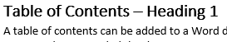

Repeat for Heading 2 – change colour to Black and text to Bold.

Creating New Styles – Heading 2
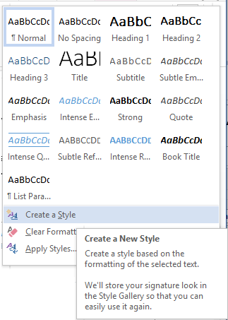
Click the ‘Create a Style’ option.

This opens a dialogue box to name the style.
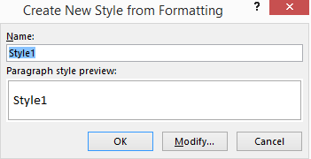
Give the style a name and click OK.

To create the style itself, follow the Modify option as above.

Activity
Find this section in the document you are working on and click on the heading Activity above
Create a style named Activity and modify it so the heading is bold and underlined
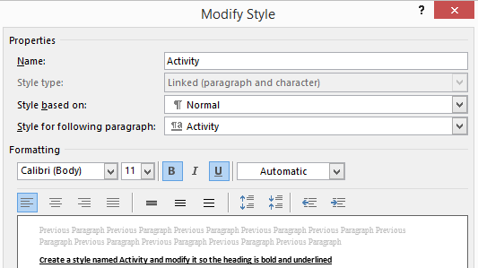

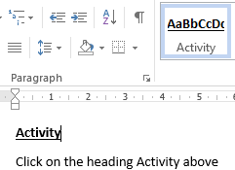

Apply this style to all of the headings in your document named Activity

Making Styles work for you – Heading 2
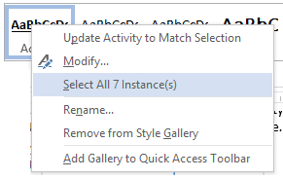
A possible use for styles is in longer documents where there might be thoughts, draft comments and follow up items. If a different style (particularly colour) is used for each type of work then it is easy to see if the final document is complete – there shouldn’t be any other colours left is the text.
By right clicking and selecting the Select All Instances option, it is possible to find which text has still to be changed over or deleted.

Creating a Table of Contents – Heading 2
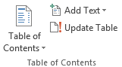
Now that we have Heading Styles in use we can create a table of contents. It is possible to navigate around the document using ctrl+click on the Table of Contents created.
Location: REFERENCES tab

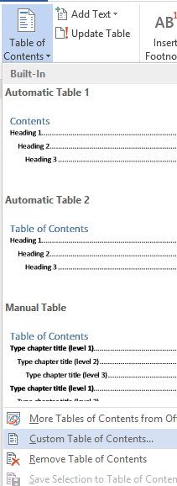
Click under the heading Contents on the Contents Page of the document

Click on the Table of Contents drop down arrow and select Custom Table of Contents

This opens the Table of Contents dialogue box.

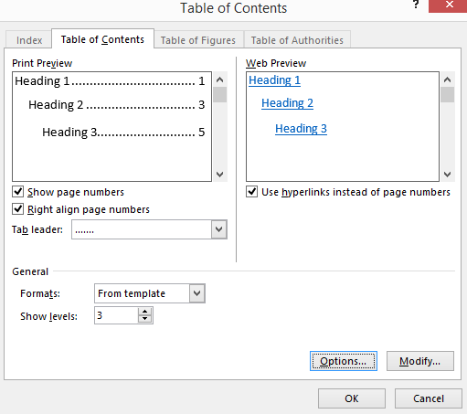
From here it is possible to create/modify the table of contents to meet your own needs.

If you have created your own Heading Styles, they may need to be mapped. To do this click on the Options button and add the TOC level next to your own heading styles (may need to scroll through the list).
A built in table of contents can also be used by choosing the appropriate option.

Activity
Add a table of contents in the correct place to your document

Some issues with the Table of Contents – Heading 2
It may not display everything as you wish it to be displayed – check the correct styles have been used
An image or chunk of paragraph text may appear within the table of contents – ctrl click on the link to take you to the part involved and then change the style to another one (eg normal).
The table of contents (and table of figures) don’t normally appear in the table of contents itself.
Therefore, the headings for these have not had a heading style applied to them however they need to have a similar structure as the heading 1 styles.
Activity
Create and apply a custom style for headings which are not to appear in the table of contents. The properties should be the same as for the current Heading 1 style. Give the style a suitable name.
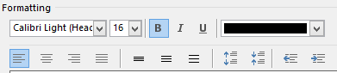
Apply to Contents Page and Table of Figures Headings on the Contents Page

Updating a Table of Contents – Heading 2
If changes are made to the document after the table of contents has been constructed, the headings and/or the page numbers will change.
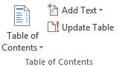
The table of contents can be updated by clicking on it and choosing the Update Table option from the Table of Contents section of the REFERENCES tab (or right clicking the table of contents and choosing the update table option).
Select the best option
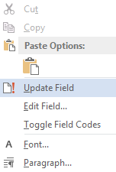
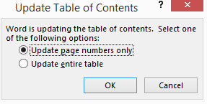
Update page numbers only – useful if only the page numbers have changed but the headings themselves are unchanged (leaves formatting unchanged)
Update entire table – useful when headings have been added or changed
Activity
Apply Heading 2 style to the heading for this section in your document
Update the entire table of contents to show this heading

Referencing – Heading 1
Referencing is made up of two parts – the inline citation and the reference list at the end of the document.

Adding APA References – Heading 2
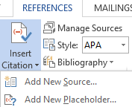
The referencing tools can be found on the REFERENCES tab
A source needs to be added before a citation can be inserted into the text.
To add new reference details either
Click Manage Sources and New, or
Choose the Add New Source from the Insert Citation option
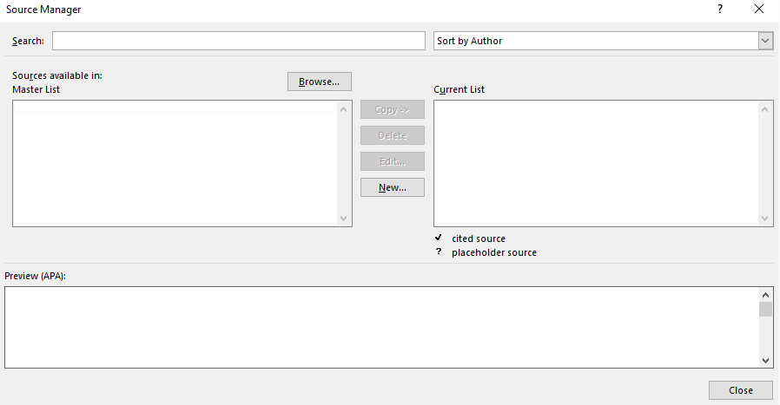
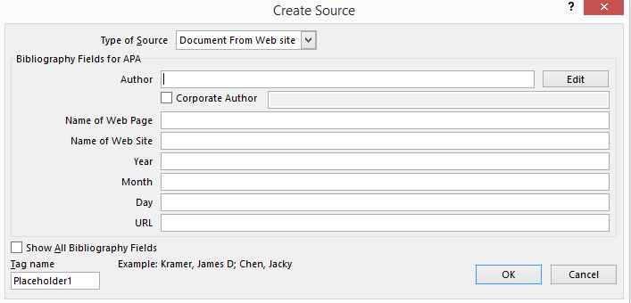
The Create Source dialogue box includes the recommended fields for each reference type but if additional fields are required select
Choose the Type of Source from the drop down list at the top of the screen
Fill in the details as required
Authors:
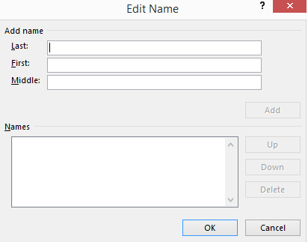
The Edit button next to the Author field allows 1 or more authors to be easily added:
Type the details into the appropriate boxes
Click Add
Continue adding author details until finished and then click OK.

Corporate Author can be used for organisations
The Master List shown in the Source Manager shows any sources previously created using the current installation of Word. It is possible to add sources from other computers or installations using the Browse option and if you have the required XML file.
Once a source is added it is available for all future documents but needs to be added to the current list using the Copy button.
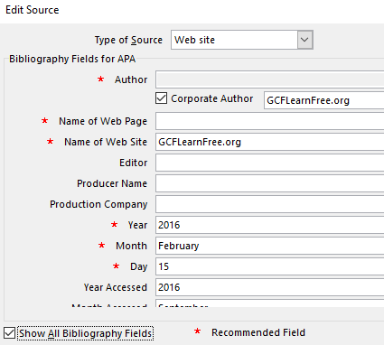
Activity
Add the following website to Sources
GCFLearnFree.org Word 2016
Date accessed should be the current date
Use the ‘Show all Bibliography fields’ option to add the date accessed details
NOTE: Your dates may be different

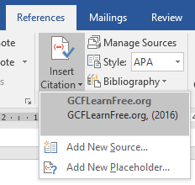
To add the citation, click at the point in the text where it is to be added and click on Insert Citation.
Click on the citation to be added (NB this can become a long list over time)
Activity
Insert a citation to GCFLearnFree.org so it looks like the following (NOTE: your year may be different)
GCFLearnFree.org has created a large number of Word 2016 tutorials which they have made freely available for others to use (GCFLearnFree.org, 2016)
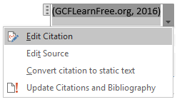
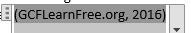
Further details can be added to a citation by clicking on the citation itself and then clicking the drop down arrow to open an additional set of options
Click on Edit Citation

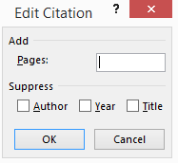
Add or suppress the required details and click OK

Creating a Reference Page – Heading 2
Go to the page where the reference list is to be created
Choose one of the options from those available from the Bibliography drop down menu
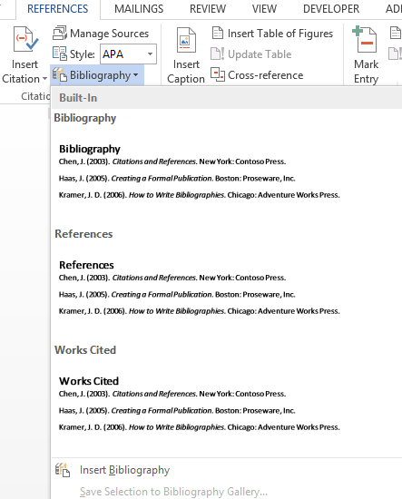
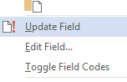
If there are no references in the current document, the following statement is shown. Leave it there because the list can be updated at a later time.
To update the reference list, right click on it and choose Update Field
Activity
Add a reference page to the end of your document (insert a page break)
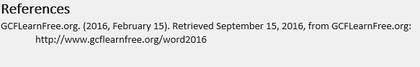
Include a heading and the reference list
Apply the Heading 1 style
Update the Table of Contents using the ‘Entire table’ option

Cross Referencing Figures – Heading 2
A cross reference can be added when figures (images, graphs and lists) are included within a document.
The advantages of adding the cross references are
Create a table of figures at the start of the document to allow easy access to particular documents
Refer to the figure within the body of the text by reference to its name or number and automatically update these when the figure is moved to a new location.

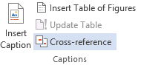
Location REFERENCES tab
To add caption text, click Insert Caption
To add cross reference in text, click Cross-reference

Activity
Figure 1: 5 Pointed Star
Add a caption to each star
Click on the 6 pointed star
Add the following text
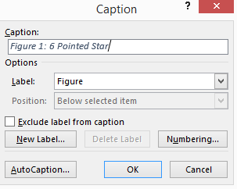

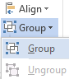
Click OK
Place the text box where required and then select both the image and the textbox and group them (Group is an option under Drawing Tool Format contextual tab).

Repeat for the 5 Pointed Star
The figure number can be updated by right clicking on the number and Updating the Field
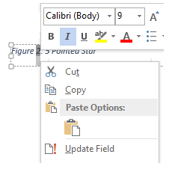

Figure 2: 6 Pointed Star

A cross reference can now be added to the text within the report
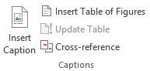
Activity
Click where the reference is to go and type (
Click Cross-reference

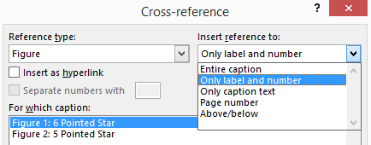
Select the options required

Click Insert then )
Repeat for the 5 Pointed star
Two types of stars are 6 Pointed (Figure 2) and 5 Pointed (Figure 1)
The Figure 1 and Figure 2 are entered as fields so mistakes can be fixed by deleting the field and starting again.
Move the images so the 5 pointed star is before the 6 pointed star
Click on the figure number which is part of each image in turn and click Update
Right click each reference in turn in the text and update it

Other Types of Cross References – Heading 2
Cross references can also be added to headings by choosing the Headings reference type
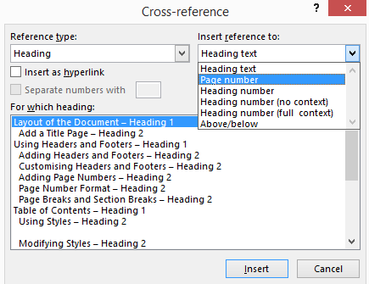
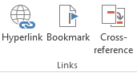
Bookmarks can be created using the Bookmark option on the INSERT tab

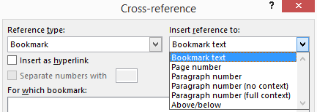
Add a name for the bookmark

Reference using the Bookmark reference type

Creating a Table of Figures – Heading 2
A table of figures can be included at the start of the document in the same way as a table of contents.
Activity
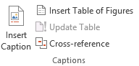
Go to the required location for the table of figures
Click Insert Table of Figures

Activity
Now that you have finished everything, look through your document and remove blank pages and move headings to new pages if you want to.
Finally update your table contents and table of figures.
Save your document (maybe save it as a pdf to keep your formatting).

A Final Word – Heading 1
There are lots of other bits and tweaks which can be added to documents.
Check out the GCFLearnFree website for useful tutorials on various topics around using computers.
Another good resource of free books is www.bookboon.com

References
GCFLearnFree.org. (2016, February 15). Retrieved September 15, 2016, from GCFLearnFree.org: http://www.gcflearnfree.org/word2016

