Installation Guide for Office 365 ProPlus for Students

Microsoft Office Applications
NMIT students can install Microsoft Office ProPlus programs on up to five personally owned devices. Different Microsoft Office applications are installed, depending on the type of device.
There are two versions of Desktop Office to choose from:
  - Office 2013 – latest version but only for Windows 7, 8 and 8.1
  - Office 2010 – older version for Windows XP SP3 or Vista (no mobile apps)

Getting started with installation
USING THE DEVICE you want to install Microsoft Office 365 onto, do the following:
- Select the Office 365 icon on the Student Portal page to load Outlook Web App
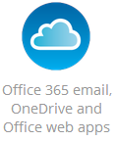
- Select the cog in the top right-hand corner

- Select ‘Office 365 settings’ option
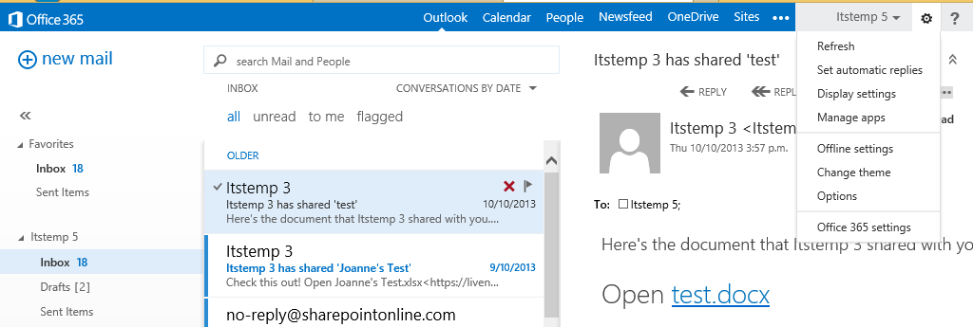

- Select Software option
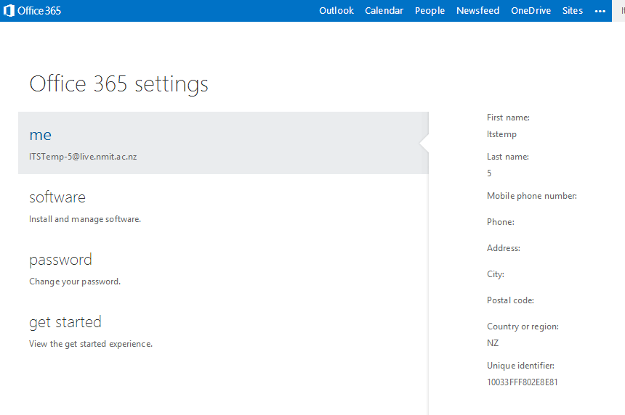

Install Microsoft Office on a personal computer
For personal computers running Windows 7, Windows 8 or Windows 8.1, use the following instructions:

- Select Office > Install to install Microsoft Office 2013 on the computer you are currently using.

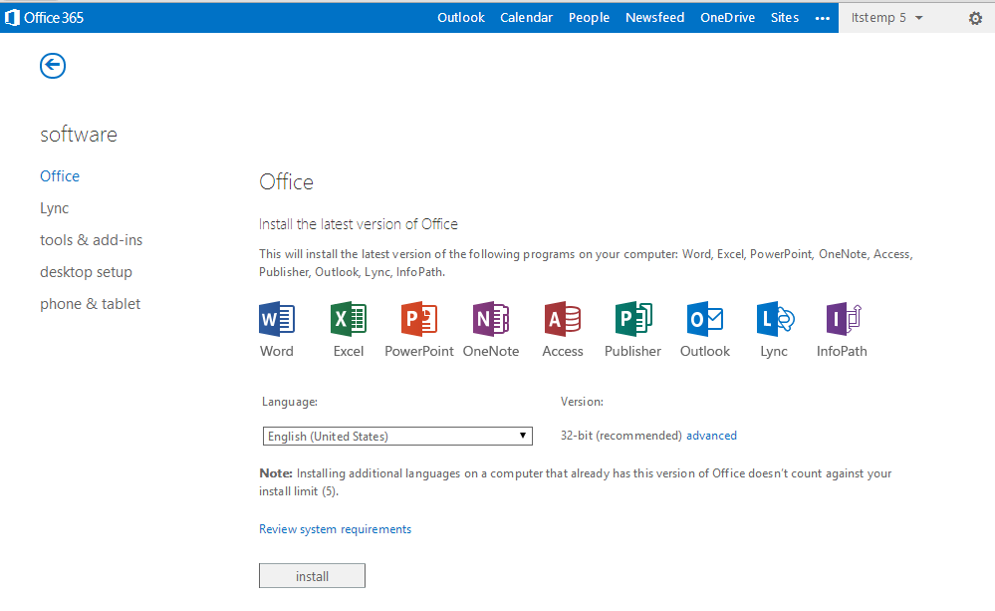

Note: If your personal computer is Windows XP or Vista then it will not support Office 2013 but Office 2010 is supported.

For personal computers running Windows XP or Vista use the following instructions:

- Select the ‘Install Office Professional Plus 2010’

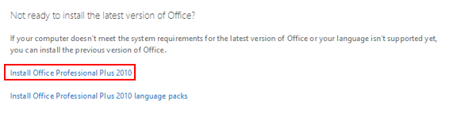

- Select ‘Install’ on the new window that is displayed.
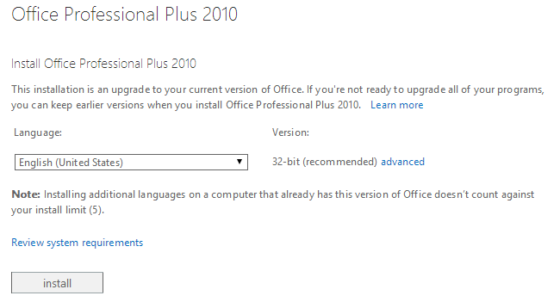

Installation of Office365 with previous versions of Office installed on PC
If you already have Microsoft Office 2010 or 2007 installed on your PC, go to Desktop Setup and click Set up
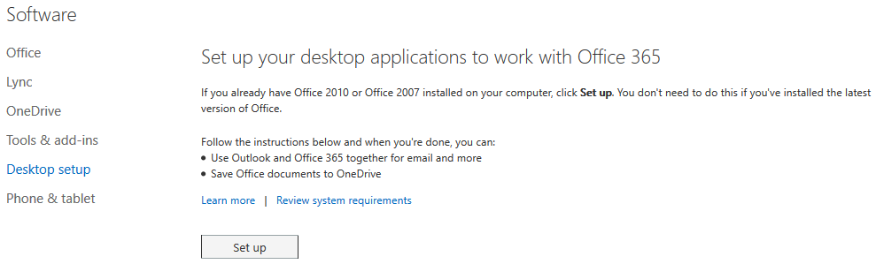

Install Microsoft Office on a Mac computer
For details on how to install Microsoft Office on a Mac computer view the short video here.
Or copy & paste this URL into your browser
http://office.microsoft.com/en-us/videos/video-install-the-latest-office-for-mac-from-office-365-for-business-VA104235799.aspx?CTT=5&origin=HA102822111

Install Office on Phones and Tablets
(NB: not compatible with Android tablets) From a personal computer, do the following:
- Follow Steps 1 – 4 from ‘Getting started with installation’.

- Select the Phone & Tablet option and then the device type (not available on Android tablet)
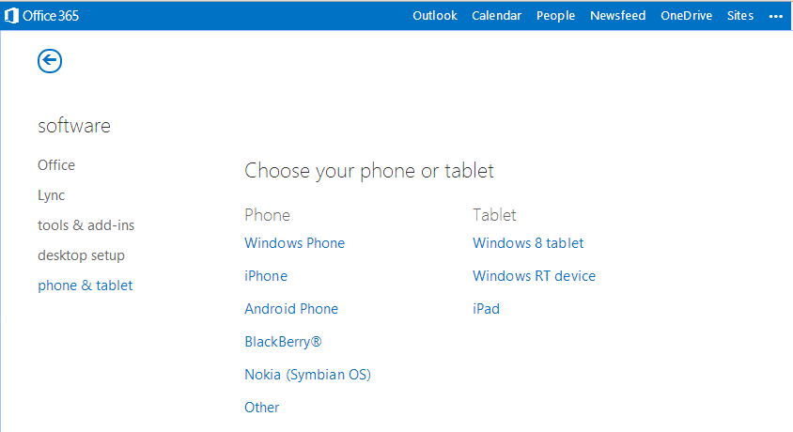
- Select ‘get Apps’.
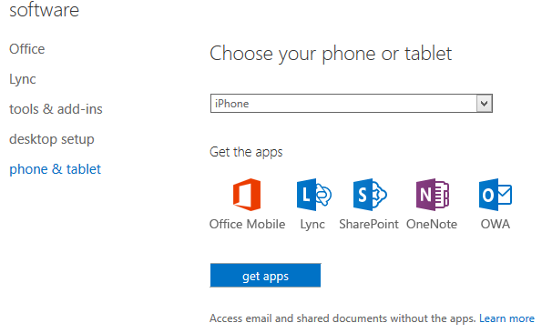
- Type in your NMIT email address and click Submit or open the following webpage on your device: www.office.com/business-apps
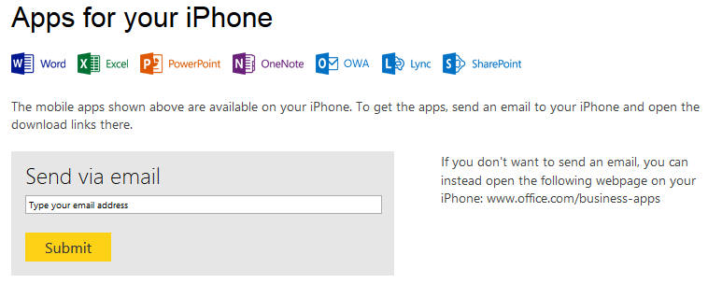
From THE DEVICE, do the following:
- Open the email on your device and follow instructions.

Disclaimer
- Not all devices will be compatible and you will receive a message advising that “Your device is not compatible with this version”.
- Not all Apps are available on all devices.

Activate or verify your software
After you have installed office 365 you may be prompted to activate or verify the software subscription. Select the option to activate with your MicroSoft account. Enter your full NMIT email address. E.g Joe-bloggs@live.nmit.ac.nz and your usual NMIT password.

Office 365 Subscription

- It is important to connect to the internet at least once every 30 days otherwise you can only view/print documents. Re-connecting restores full functionality (as long as you are still a student!)

- Three months after your course end date, your Office 365 subscription will expire and you will only be able to view/print documents. You will not be able to create or edit. To continue using Microsoft Office you will need to subscribe.

