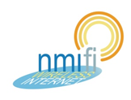
CONNECTING TO NMIFI

Wireless is available throughout the campuses
- Turn on wireless on your computer
- Select the NMIFI network to connect to our network
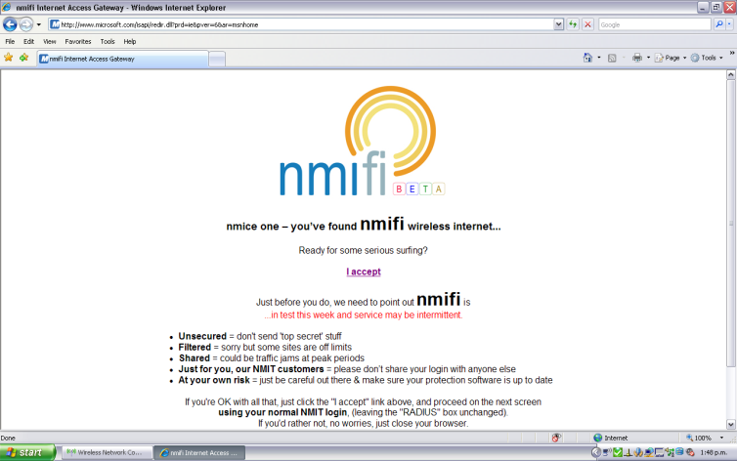
- Open a web browser which will display the NMIFI welcome page

- If you do not see this page, key in the following address http://www.nmit.ac.nz/
- Read the service terms, click the ‘I accept’
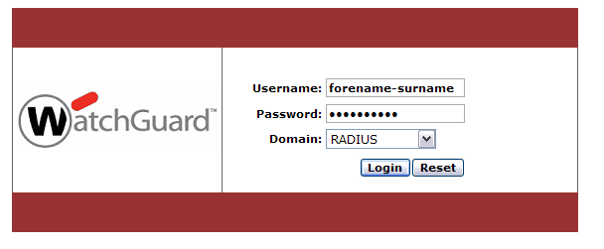
- Login to WatchGuard login page to access wireless services

- Use your normal NMIT login (firstname-lastname). Leave Domain as Radius.

