Hello Lynn,

Navigate to you OneDrive and click "Add new" then "Files upload" in the top left corner.

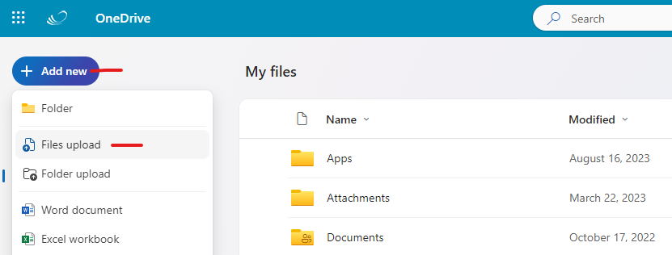

Find where the file is saved on your computer, click the file, then click "Open".

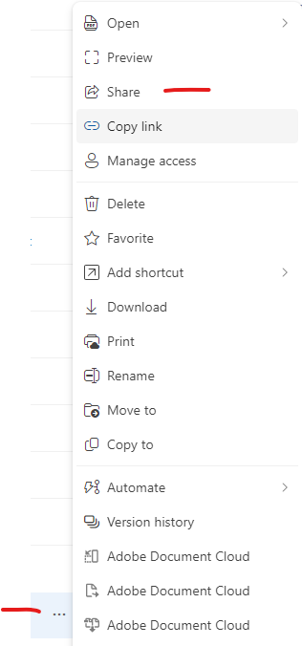

The file should now be uploaded to OneDrive. Once it is uploaded click the three dots next to the file and click "Share".

Enter the email of who you want to send the link to, then click "Send"

